

**Characteristics and impact factors for the development of energy technologies in the building sector**

**Václav Novák, Czech Republic**

**Maria Hecher, Austria**

Co-operating Universities

   

Financial support by

 

**Prague and Vienna, 2012**

# Content

1 Abstract 3

2 Introduction 3

3 Approach 5

4 Characteristics of the residential building sector in Austria and the Czech Republic 5

4.1 The residential building sector in Austria 6

4.2 The residential building sector in the Czech Republic 9

5 Impact factors of the residential building sector in Austria and the Czech Republic 13

5.1 Legal framework in Austria and the Czech Republic 13

5.2 Economic impact factors in Austria 14

5.3 Economic impact factors in the Czech Republic 17

5.4 Other important impact factors of the residential building sector 19

6 Comparison of Austria and the Czech Republic 21

7 Conclusions 22

8 List of figures 23

9 References 24

# Abstract

*The building sector utilised for residential, commercial and public purposes is responsible for a significant proportion of the total energy demand in a country. Besides energy necessary for the construction and demolition, operating energy for heating, cooling, ventilation, hot water, powering appliances and lightning is responsible for the largest part of the energy demand in buildings. It is therefore essential to achieve a sustainable development in the use phase of a building by both, an overall reduction in energy consumption through energy efficiency and the use of renewable energy carriers for energy technologies.*

*Focussing on residential buildings, first an analysis of the energy efficiency of buildings as well as currently used energy technologies in Austria and the Czech Republic is made. Second, the impact factors are identified respectively, attracting on economic factors like investment and operational costs, subsidies and taxes. Additionally other important aspects such as socio-economic factors, information sources and system-related factors are identified having a considerably impact on households’ decision making. Finally, the characteristics and impact factors of the development pathways in Austria and the Czech Republic are compared with each other. The results show the main characteristics, impact factors and differences of both, the energy efficiency of buildings and the application of energy technologies in two European countries.*

*Based on this analysis, the effectiveness and impact of different policy measures can be evaluated and assessed. Results and conclusions will be added here …*

# Introduction

The building sector utilised for residential, commercial and public purposes is responsible for a significant proportion of the total energy demand in a country. Besides energy necessary for the construction and demolition of buildings, operating energy for heating, cooling, ventilation, hot water, powering appliances and lightning is responsible for the largest part of the energy demand in buildings (Ramesh et al., 2010; Satori & Hestnes, 2007). It is therefore essential to achieve a sustainable development in the use phase of a building. An overall reduction in energy consumption is achieved by both, an overall reduction in energy consumption through energy efficiency and the use of renewable energy carriers for energy technologies.

In the following figures the development of the final energy use in Austria and the Czech Republic is shown by sectors. In both countries it can be seen that there is an enormous potential for energy savings in private households. In Figure 1 the development of the final energy use in Austria from 1970 till 2010 is illustrated, showing that the energy use has almost doubled since 1970. However, it can be seen that private households have a considerably share of the total energy use in Austria. In 2010 private households consume approximately 25% of the total final energy (Statistics Austria, 2010). In the Czech Republic the reduction of the final energy consumption, which occurred in the past three years, stopped. In 2010 the energy consumption increased by 8,2% explained by the economic recovery and the production growth in the economy. In 2009 the industrial sector has the highest energy consumption with 33,2% followed by transport with 27.4% and private households with 25.2%. Both figures show that private households in Austria and the Czech Republic represent a significant potential for energy savings.

Figure 1: Development of final energy use by sector in Austria 1970 – 2010  
(Statistics Austria, 2010)

Figure 2: Development of final energy use by sector in the Czech Republic 1999 – 2009  
 (ISSaR, 2011)

*Introduction will be completed …*

# Approach

Focussing on residential buildings, first an analysis of the energy efficiency of buildings as well as currently used energy technologies in Austria and the Czech Republic is made. Second, the impact factors are identified respectively, attracting on economic factors like investment and operational costs, subsidies and taxes. Additionally other important aspects such as socio-economic factors, information sources and system-related factors are identified having a considerably impact on households’ decision making. Finally, the characteristics and impact factors of the development pathways in Austria and the Czech Republic are compared with each other. The results show the main characteristics, impact factors and differences of both, the energy efficiency of buildings and the application of energy technologies in two European countries. Based on this analysis, the effectiveness and impact of different policy measures can be evaluated and assessed.

# Characteristics of the residential building sector in Austria and the Czech Republic

In the following the characteristics of the residential building sector in Austria and the Czech Republic is described. After illustrating the residential building and dwelling stock in both European countries, the construction period of dwellings is shown. Additionally, the most important statistics of heating systems and their energy carriers are described respectively. Finally, the total energy demand for the residential sector in both countries is illustrated.

## The residential building sector in Austria

The Austrian building stock illustrated in Figure 3 is continually increasing from 1,28 million buildings in 1971 to 2,05 million buildings in 2001. Besides 2,05 million buildings in 2001, 3,86 million dwellings have been counted in Austria used for residential purposes. About 0,28 million buildings and 0,11 million dwellings are counted in the category non-residential buildings. It is remarkable that 76% of all Austrian buildings belong to the category “1 or 2 dwellings”. Only 14% of the total building stock belongs to the category “non-residential buildings” (Statistics Austria, 2007).

Figure 3: Residential and non-residential buildings and dwellings in AT 1971 - 2001   
(Statistics Austria, 2007)

In Figure 4 the construction period of the Austrian dwelling stock is shown. It can be seen that dwellings constructed before 1980 decrease significantly since 1985. In 1985 about 91% of the total dwelling stock was constructed before 1980, compared to solely 66% in 2010 (Statistics Austria, 2012). However, 66% of the Austrian dwelling stock is still constructed before 1980, having a high energy demand. Buildings constructed after 1980 are far more energy effiencient. Thus, the future potential for overall energy savings and energy efficiencies lies in the refurbishment of the current, not refurbished building stock (Müller et al. 2010).

Figure 4: Construction period of the dwelling stock in AT (main residences) 1985 – 2010   
(Statistics Austria, 2012)

Considering the used energy technologies for space heating and domestic hot water in the Austrian dwelling stock, central heating systems represent 64% in 2010 and are by far the mostly used heating systems (Figure 5). Since 2003 central heating systems are slightly increasing. District heating systems are on the second position and are continually increasing since 2003. In 2010 district heating systems have a share of 23% of the total heating system installations. Individual stoves, electric heating and gas convectors are energy technologies slightly decreasing between 2003 and 2010. In sum these energy technologies have a share of only 14% (Statistics Austria, 2011).

The energy resources used for heating purposes is shown in Figure 6. The dominating energy carriers are still fossil fuels, although the share is decreasing. In 2004 a share of 62% of the total heating systems use coal, lignite, oil, gas or electricity as energy carriers. In 2010 this share decreases to 55%. Figure 6 illustrates that the share of heating systems using renewable energy carriers or district heat is increasing from 38% in 2004 to 45% in 2010 (Statistics Austria, 2011).

Focussing on the energy consumption in Austrian households, Figure 7 illustrates that in average 71% of the total energy consumption is used for space heating, 13% for domestic hot water and 3% for cooking. In the year 2010 this corresponds to 196.767 TJ for space heating, 33.032 TJ for domestic hot water and 7.406 TJ for cooking. The remaining 37.371 TJ are used for other purposes. Between 2003 and 2010 the total energy consumption in the household sector increased slightly with 2%.

Figure 5: Heating systems of dwellings in AT (main residences) 2003 - 2010   
(Statistics Austria, 2011)

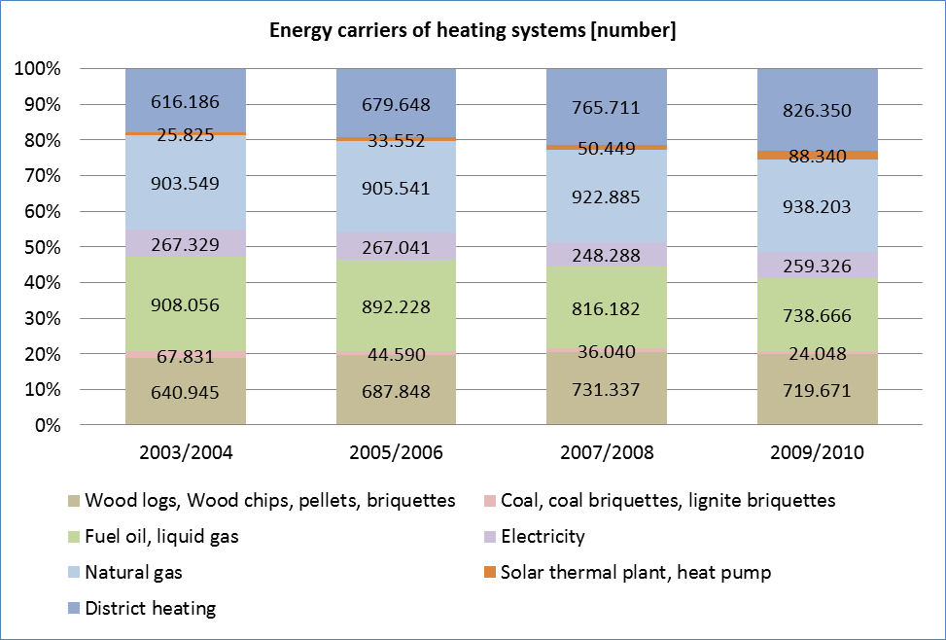

Figure 6: Energy carriers used in dwellings in AT (main residences) 2003 – 2010*[1]   
(Statistics Austria, 2011)

Figure 7: Energy consumption for space heating, domestic hot water and cooking   
in AT 2003 - 2010 (Statistics Austria, 2010)

## The residential building sector in the Czech Republic

In the Czech Republic the number of dwellings is increasing since 1961 as can be seen in Figure 8. The number of dwellings is increasing, however the growth rate decreases. In Figure 9 the proportion of the number of dwelling units in buildings in 2001 is shown (Statistics CSU, 2004).

Figure 8: Dwellings in CZ 1961 - 2011 (Statistics CSU, 2012)

Figure 9: Dwelling size in CZ 2001 (Statistics CSU, 2004)

In Figure 10 the construction period of the dwelling stock in the Czech Republic in 2011 is demonstrated. It can be seen that the share of new constructed dwellings (1991-2001) is low. However, a significant reconstruction of dwellings on the one hand and the refurbishment of old dwellings on the other are reflected in the age structure. The average age of the dwelling stock is about 47 years, while buildings with 1 dwelling are on average 2.5 years older than buildings with 2 or more dwellings. New constructed or refurbished dwellings represent solely 10% of the whole dwelling stock. This situation is improving in previous decades. Dwellings built or refurbished between 1961 and 1991 constitute almost 43% (average of 14% per decade) of the total dwelling stock. Almost every sixth dwelling is older than 80 years and more than 8% of the dwellings are even older than 100 years (Statistics CSU, 2004).

Figure 10: Construction period of dwelling stock in CZ 2001   
(Statistics CSU, 2004)

Figure 12 shows the share of individual types of heating systems and their development between 1961 and 2011. The figure illustrates that central and local heating systems sharply increased since 1961, while the number of stoves sharply decreased (Statistics CSU, 2012).

In Figure 11 the development of energy carriers used for heating systems in the Czech Republic is shown for the years 2001 and 2011. It can be seen that the energy carrier of natural gas, electricity and wood increased since 2001, while coal and district heating increased. However, district heating is still very frequent using waste heat from power plants for transmission of heat is used steam (Statistics CSU, 2012).

In Figure 13 the purpose of energy consumption in the building sector of the Czech Republic is illustrated. Between 1996 and 2003 the energy consumed for space heating decreased from 73,45 PJ to 59,40 PJ. Also the energy consumed for domestic hot water declined from 11,43 PJ to 8,4 PJ (Statistics CSU, 2005).

Figure 12: Heating systems of dwellings in CZ 1961 – 2011 (Statistics CSU, 2012)

Figure 11: Energy carriers used in dwellings in CZ 2001 and 2011   
(Statistics CSU, 2012)

Figure 13: Energy consumption for space heating, domestic hot water and cooking in CZ 1996 and 2003 (Statistics CSU, 2005)

# Impact factors of the residential building sector in Austria and the Czech Republic

In the following the focus is set on the most important impact factors influencing the development of the residential building sector in a country and especially households’ decision-making for specific heating systems. After describing the legal framework in Austria and the Czech Republic having an essential impact on the quality of the building stock, we attract on economic factors influencing the market development of heating systems in both countries. Concerning the fact that households’ decision-making for heating systems is not solely affected by economic factors, an attempt is made to identify additional factors having a considerably influence on these decisions.

## Legal framework in Austria and the Czech Republic

The *EU Directive of the Energy Performance of Buildings 2002/91/EG (EPBD)* is the main legislative instrument affecting energy use and efficiency in the building sector, hence the quality of the Austrian and Czech building stock. The directive tackles both, new and refurbished buildings by requesting the implementation of energy certificates for these buildings (EU, 2002).

Austria implemented this directive in 2008 by enacting the *“Energieausweis-Vorlage-Gesetz (EAV-G)”*, which means that for all new and refurbished buildings an energy certificate is required. Since 2009 this is obligatory also for existing buildings (Mach & Heimrath, 2010). The main motivation behind this directive is not only a considerably reduction of the energy demand of buildings but also a harmonized standard for the calculation and evaluation of the energy demand of buildings in the European Union (Streicher, 2012). Since 2010 a new *EU Directive of the Energy Performance of Buildings 2010/31/EU (EPBD)* exists. This directive is proscribing that for all new buildings the possible use of renewable energies have to be evaluated and have to be built as nearly zero energy buildings by 2020 (EU, 2010).

Besides these directives, each federal state in Austria has its own building code, however referring on the harmonized *Directive of Energy Saving and Thermal Insulation.* It is part of the *Construction Products Directive (CPD)* worked out by the Austrian Institute of Construction Engineering (OIB). In 2008 all federal states in Austria agreed to implement this directive which defines both, upper limits for U-values of structural elements in buildings (f. e. walls, roofs, doors, windows, etc.) as well as upper limits for the heating energy demand (kWh/m²a) (OIB, 2007). The following figure demonstrates the development of the U-value requirements of several structural elements in buildings including the anticipated passive house standard in 2020 (TZB, 2010).

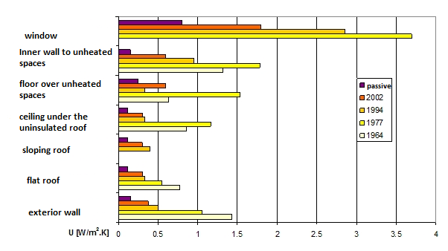

Figure 16: Development of standardised thermal transmittance values (Standardized value CSN 730540) (TZB, 2010)

## Economic impact factors in Austria

In order to compile the impact of economic factors on households’ decisions concerning the choice of their heating system, the representation of both, the respective Austrian market development of heating systems and the causes for these developments is considered to be a suitable instrument. In this part, first the market development of heating systems based on renewable energy are described and illustrated between 2001 and 2010, followed by a description of heating systems based of fossil fuels by focussing rather on the potential of future developments.

In the following figure the market development of heating systems based on renewable energy is illustrated. The first category of biomass boilers includes all boilers with an installed capacity less or equal than 100 kW using pellets, wood logs and wood chips as energy carriers. The figure illustrates the number of biomass boilers annually sold in Austria between 2001 and 2010. Also included in this category, but shown separately in the figure, are individual biomass stoves using pellets and wood logs as energy carriers. The number of annually sold stoves in Austria is in this case solely available from 2008 to 2010. Additionally, in Figure 14 the amount of area of solar thermal collectors annually installed as well as the number of heat pumps annually sold in Austria between 2001 and 2010 is shown (Biermayer et al., 2011).

Figure 14: Market development of heating systems based on renewable energy   
in Austria 2001 – 2010 (Biermayer et al., 2011)

Biomass boilers with an installed capacity less or smaller than 100 kW are typically applied as central heating systems in single or multiple family houses as well as office or commercial buildings. The annual sales of these biomass boilers are continuously increasing in the period 2001 to 2006. However, the development shows an enormous decrease of 60% in 2007 as can be seen in Figure 14. This is mainly explained by both, a decrease in the growth rate of the oil price and an enormous increase of the pellets price. The development of the oil and pellets price between 2000 and 2010 is illustrated in Figure 15. The background for the significant change of the pellets price is a temporary shortage of pellets due to a strongly growing demand and the limited production capacities for this energy carrier. In 2008 annual sales of biomass boilers rose again to an even higher number compared to 2006, however since then a decrease could be observed till 2010. The main causes for this reduction are on the one hand the delayed impact of the financial crises and on the other hand the decrease of the maximum amount of subsidies in two decisive Austrian federal states (Biermayer et al., 2011).

The development of annual sales of solar thermal collectors is also illustrated in Figure 14. Between 2001 and 2009 the annual installation of solar thermal collectors is constantly and slightly increasing. This fact is mainly explained by both, an increase in energy prices especially the oil price as can be seen again in Figure 15, and new fields of application like systems for hot water combined with space heating at the same time expanding the use recently solely for single family houses to multifamily houses and the tourism sector. From 2009 to 2010 the annual sales of thermal collectors decreased by 21%. On the one hand this is caused due to the delayed impact of the financial crises as well as the sharply fall in the investment costs of photovoltaic cells (Biermayer et al., 2011).

Figure 15: Development of oil price and pellets price in Austria 2000 - 2010   
(Austrian Energy Agency, 2012; proPellets Austria, 2012)

Heat pumps are versatile applicable for space heating, domestic hot water as well as ventilation purposes in several different capacity categories. Heat pumps show a remarkably development of annual sales having an enormous increase between 2001 and 2008, however show a decrease of 3,1% between 2008 and 2010. The main reasons for the constant increase are the favourable framework conditions in energy efficient buildings recording low heating requirements, the further development of the technology and developed quality mechanisms for installation. The slightly decrease of 3,1% is explained through multiple factors. First, the financial crisis has an impact on the construction rate of new buildings consequently affecting annual sales of heat pumps predominantly applied in new buildings. Second, restrictive credit conditions for private investors induce the same effect just described. Finally, a high subsidy for oil boilers from the Austrian oil industry since 2009 considerably affects the market development of heat pumps (Biermayer et al., 2011).

After describing the market development of all heating systems using renewable energy sources, in this part the focus is set on heating systems based on fossil fuels. Currently and in future, the importance of heating systems based on coal resources (hard coal, coal briquettes, lignite briquettes, etc.) is rather low in Austria. It is expected that the coal price will increase in terms of national taxes. Due to the fact that the combustion process of coal induces high CO2-emissions a future CO2-tax is likely to be implemented. Additionally, no national subsidies for coal boilers are expected, leading to the conclusion that the use of coal boilers is a discontinued model in an observation period till 2050 (Müller et al., 2010).

Until the 1970s the oil boiler is representing the standard heating system applied in the residential sector. Only through an enormous increase in the oil price new heating technologies entered the market. The oil price is one of the crucial impact factors for the market development of oil boilers, which in the long run is expected to increase due to the scarcity of oil resources. A second crucial impact factor besides the oil price constitutes the national subsidy scheme. As already mentioned above, oil boilers are strongly supported from the Austrian oil industry since 2009. With the current subsidy amount it is possible to annually support 7.500 boilers (Müller et al., 2010). This fact increases the use of oil boilers mainly at the expense of heat pumps and biomass boilers (Biermayer et al., 2011).

Compared to coal and oil boilers no effective restraints are expected regarding the future development of heating systems based on natural gas. Gas boilers are available in several different capacity categories to be applied not only in old, not refurbished buildings, but also in buildings having a nearly zero energy standard. Besides the wide range of application, low exhaust gas values, the combined supply of space heating and domestic hot water, and the relatively low investment costs constitute a strategic advantage for gas boilers. Nevertheless, the future development is again especially dependent on future gas prices (Müller et al., 2010).

By reflecting the market development of different heating systems and their respective reasons it becomes clear that economic impact factors play a crucial role in the past and in the future development of respective heating systems. Besides investment costs, the fuel prices of renewable and fossil fuels play a remarkable role. Investment and operational costs are additionally dependent on the subsidy regimes in a country as well as national taxes, in the meantime reflecting the main interests of a country.

## Economic impact factors in the Czech Republic

In the Czech Republic the most important aspects influencing the development of heating systems are economic factors. The first is the subsidy and tax policy of the state, the second is the development of fuel prices and the third are the investment costs of each technology. In the next table an overview of the Czech tax policy with taxes influencing household’s energy consumption patterns is illustrated. The development is characterised by a gradual introduction of energy taxes. This leads in the first place to more pressure on newly constructed buildings with higher energy efficiencies. Another phenomenon is the increasing consumption of cheaper sources in households such as coal, wood or even the incineration of waste, which in some regions significantly deteriorates the air quality.

Table 1: Energy taxes in the Czech Republic (Energostat, 2012)

|  |  |  |  |  |  |
| --- | --- | --- | --- | --- | --- |
| **Energy taxes in Czech republic** | | | | | |
| **Tax** |  | **Rate** | **Taxpayer / payer (****)** | **Year of introduction** | **Validity** |
| **Emission fees (/)** | | **Solid pollutants = 3,000 CZK / t**  **SO2 = 1 000 CZK / t**  **NOx = 800 CZK / t**  **VOC = 2 000 CZK / t** | **Energy companies and heating plants** | **1991** | **unlimited** |
| **"Green taxes"** | **tax on natural gas** | **30,60 Kč/MWh (x)** | **The final consumer / supplier** | **2007** | **unlimited** |
| **tax on fossil fuels (ie coal)** | **8,50 Kč/GJ** |
| **tax on electricity** | **28,30 Kč/MWh** |
| **"Allowance tax"**  **(gift tax on CO2 allowances)** | | **32 % (xx)** | **Energy companies and heating plants (*)** | **2010** | **2011-2012** |
| **"Solar tax" (**)** | | **26 % / 28 % (***)** | **Manufacturers of power. of PVP / transmission or distribution system** | **2010** | **2011-2013** |
| **"Carbon taxes" (+)** | **Taxation of energy content of fuel** | **0,15 - 8,9 € /GJ (+++)** | **households, businesses (+ + + +)** | **2013** | **unlimited** |
| **Taxation of CO2 (+ +)** | **15 €/t CO2** | **2014** |

Legend:

(/) ... currently preparing a comprehensive amendment to the Clean Air Act; change will also affect the amount of emission charges and the shallowness of their time, more information in a special issue, dedicated to this issue

(x) ... tax rate actually ranges from 0 - 264.80 CZK / MWh by use of gas, the tax base is the amount of gas in MWh heat of combustion, this rate 30.60 / MWh, for example, relates to gas for heating

(xx) ... the price of emission allowances

(*) ... Act (Amendment z.č.180/2005 arranged from 2010) misleading gift tax allowances to specify payer / payers of this " allowances taxes" from other schemes shows that they are all operator, emitting greenhouse gases (ie all companies covered by the Act No. 695/2004 on conditions for trading in greenhouse gas emissions)

(**) ... The official name: "removal of electricity from solar radiation"

Another important element is the development of construction standards currently under European legislation.

(***) ... Rate refers to the amount the producer receives for electricity produced from PVP, 26% rate applies in the case of payment by means of the purchase price, the rate of 28% for payment by means of green bonus;

(****) ... taxpayer actually pays tax to the payer provides payment of the tax state

(+) ... Still in draft stage, the Government of the CR (April 10, 2012) is based on Directive 2003/96/EC; folder "carbon tax" taxation of the energy content of fuel does not yet have the name of the Czech equivalent

(+ +) ... Governments in a statement defined in this part of the Republic "carbon tax" as the emission component of the excise duty on heating oil, solid fuel taxes and taxes on natural gas and other gases

(+ + +) ... Vary depending on the energy content of fuel

(+ + + +) Component ... CO2 tax will not apply to entities with the obligation to purchase emission allowances

In the Czech Republic no coherent state policy of subsidies exists. It is currently appearing in short-term grant programs at the regional or municipal level, but no significant effect on the situation in the Czech Republic is raised.

The share of the total thermal energy production from renewable energy sources is around 8%. This proportion is based on an estimation from the total gross production of thermal energy of about 700 PJ in 2007. It is assumed that the total heat production in recent years is roughly the same (including households and industry). The total estimated amount of thermal energy from renewable sources does not yet include biomass used in small non-household sources and biomass consumed for heating of the individual recreation of the population (MPO, 2011).

It can be seen that economic factors are the most important factors influencing households’ choice for a specific heating system or the decision to change to an alternative heating technology. It is obvious that an increase in fuel prices of conventional energy carriers lead to the incentive to improve building insulations and to change the heating system. It is assumed that the trend moves toward renewable energy carriers, especially wood and pellets. Furthermore, the segment is likely to develop with heat pumps.

## Other important impact factors of the residential building sector

As already illustrated above, economic impact factors like investment and operational costs play a leading role in terms of households’ decision for a specific heating system. However, households’ decisions are not solely influenced by economic factors. There are several empirical studies focussing on different factors having an impact on households’ decision of heating systems. Besides economic factors, Vinterbäck (2000) included technical and environmental factors as well as the degree of comfort. Sopha et al. (2010) focused on socio-demographic factors, the communication among households, heating system attributes and the applied decision strategy. Sopha et al. (undated) emphasized the importance of the social network structure influencing the diffusion of heating systems.

Mahapatra & Gustavsson (2008) carried out a study analysing the factors that influence the adoption of innovative heating systems by Swedish households. The systems studied were district heating, heat pumps and pellet boilers and the focus was set on Swedish households currently using resistance heaters. The results show that the age of homeowners is an influencing factor as older homeowners are less likely to install a new heating system. A second *socio-economic factor* is the income of households. The proportion of households planning to install a new heating system rises as the income of households increases. A crucial factor affecting households’ choice for a new heating system is the *source of information*. Households planning to install a new heating system gather information from the mass media (f. e. television, newspapers, Internet, etc.), interpersonal sources (f. e. neighbours, relatives, friends, etc.) and agents like energy agencies, local energy offices, magazines and installers. Finally, the study included ten *system-related factors:*

* annual cost, investment cost and market value of the home (economic)
* functional reliability (technical)
* indoor quality and system automation (degree of comfort)
* environmental benignity, greenhouse gas emission and security of fuel supply (environmental and supply security)
* time required for the collection of information (information provision)

Statistical analysis show that in general factors such as annual costs, investment costs, functional reliability and indoor air quality are of greater importance than factors such as system automation, environmental benignity, greenhouse gas emission and market value of the home. It was found that the time required to collect information is the least important factor. The results of the study show that socio-economic factors, information sources and system-related factors are of high importance regarding household’s decision for an innovative heating system. However, the importance of all these factors varies between households with different existing heating systems (Mahapatra & Gustavsson, 2008).

# Comparison of Austria and the Czech Republic

Will be concluded …

Figure 17; Development, price of Electrical energy for domestic custumers, Excluding taxes; (2012; EUROSTAT)

Figure 18: Development, price of Natural gas for domestic custumers, Excluding taxes; (2012; EUROSTAT)

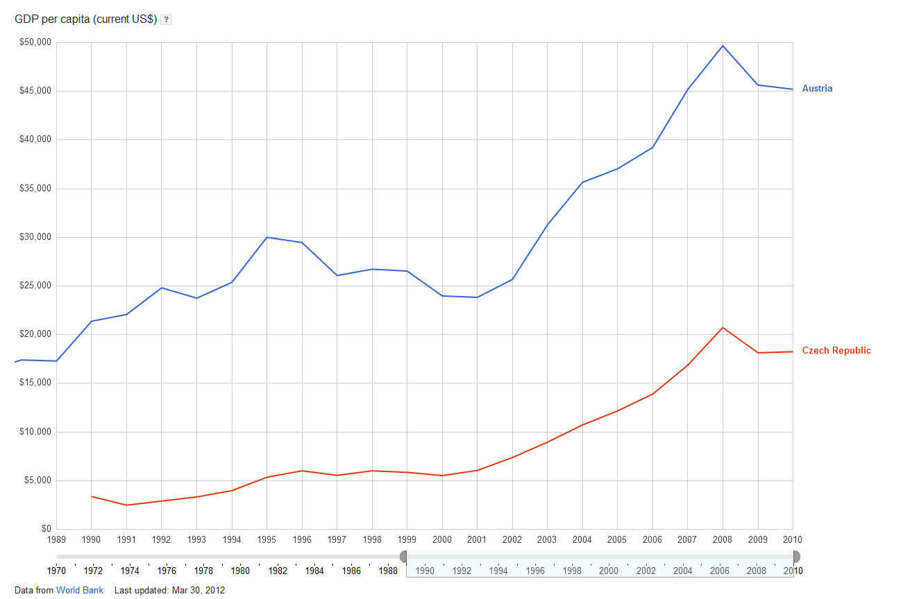

Figure 19: GDP per capita, current USD (Google public data explorer; 2012)

# Conclusions

Will be concluded …

# List of figures

Figure 1: Development of final energy use by sector in Austria 1970 – 2010 (Statistics Austria, 2010) 4

Figure 2: Development of final energy use by sector in the Czech Republic 1999 – 2009 (ISSaR, 2011) 5

Figure 3: Residential and non-residential buildings and dwellings in AT 1971 - 2001 (Statistics Austria, 2007) 6

Figure 4: Construction period of the dwelling stock in AT (main residences) 1985 – 2010 (Statistics Austria, 2012) 7

Figure 5: Heating systems of dwellings in AT (main residences) 2003 - 2010 (Statistics Austria, 2011) 8

Figure 6: Energy carriers used in dwellings in AT (main residences) 2003 – 2010* (Statistics Austria, 2011) 8

Figure 7: Energy consumption for space heating, domestic hot water and cooking in AT 2003 - 2010 (Statistics Austria, 2010) 9

Figure 8: Dwellings in CZ 1961 - 2011 (Statistics CSU, 2012) 10

Figure 9: Dwelling size in CZ 2001 (Statistics CSU, 2004) 10

Figure 10: Construction period of dwelling stock in CZ 2001 (Statistics CSU, 2004) 11

Figure 12: Heating systems of dwellings in CZ 1961 – 2011 (Statistics CSU, 2012) 12

Figure 11: Energy carriers used in dwellings in CZ 2001 and 2011 (Statistics CSU, 2012) 12

Figure 13: Energy consumption for space heating, domestic hot water and cooking in CZ 1996 and 2003 (Statistics CSU, 2005) 13

Figure 16: Development of standardised thermal transmittance values (Standardized value CSN 730540) (TZB, 2010) 14

Figure 14: Market development of heating systems based on renewable energy in Austria 2001 – 2010 (Biermayer et al., 2011) 15

Figure 15: Development of oil price and pellets price in Austria 2000 - 2010 (Austrian Energy Agency, 2012; proPellets Austria, 2012) 16

Figure 17; Development, price of Electrical energy for domestic custumers, Excluding taxes; (2012; EUROSTAT) 21

Figure 18: Development, price of Natural gas for domestic custumers, Excluding taxes; (2012; EUROSTAT) 21

Figure 19: GDP per capita, current USD (Google public data explorer; 2012) 22

# References

**Austrian Energy Agency (2012).** *Entwicklung der Ölpreise in Rotterdam (Barrel Brent)* [online]. Available from: [http://www.energyagency.at/energie-in-zahlen/energiepreise/ oelpreise.html](http://www.energyagency.at/energie-in-zahlen/energiepreise/%20oelpreise.html) [Accessed 21 April 2012].

**Biermayr, P., Eberl, M., Ehrig, R., Fechner, H., Galosi, A., Kristöfel, C., Prüggler, N., Strasser, C., Weiss, W., Wörgetter, M. (2010).** *Innovative Energietechnologien in Österreich. Marktentwicklung 2010. Biomasse, Photovoltaik, Solarthermie und Wärmepumpen.* Berichte aus Energie- und Umweltforschung 26/2011.

**Czech Statistics Organisation (2012).** *CSU: Obydlené byty podle převládajícího způsobu vytápění, energie používané k vytápění a vybavenosti plynem podle velikostních skupin obcí* [online]. Available from: [http://www.czso.cz/csu/2012edicniplan.nsf/t/95003 39D81/$File/pvcr121.pdf](http://www.czso.cz/csu/2012edicniplan.nsf/t/95003%2039D81/$File/pvcr121.pdf) [Accessed 2. April 2012].

**Czech Statistics Organisation (2005).** *CSU: Základní porovnání zjištěné konečné spotřeby* [online]. Available from: [http://www2.czso.cz/csu/2005edicniplan.nsf/t/F100 46F771/$File/8109ta7p.pdf](http://www2.czso.cz/csu/2005edicniplan.nsf/t/F100%2046F771/$File/8109ta7p.pdf) [Accessed 2. April 2012].

**Czech Statistics Organisation (2004).** *CSU: Charakteristiky trvale obydleného bytového fondu* [online]. Available from: [http://www.scitani.cz/csu/2004edicniplan.nsf/t/C2002DD521 /$File/4.pdf](http://www.scitani.cz/csu/2004edicniplan.nsf/t/C2002DD521%20/$File/4.pdf) [Accessed 15. April 2012].

**Energostat (2012).** *Energy taxes in the Czech Republic* [online]. Available from: <http://energostat.cz/energeticke-dane.html> [Accessed 15. April 2012].

**EU (2010).** *Directive 2010/31/EU of the European Parliament and of the Council of 19 May 2010 on the Energy Performance of Buildings.*

**EU (2002).** *Directive 2002/91/EG of the European Parliament and of the Council of 16 December 2002 on the Energy Performance of Buildings.*

**EUROSTAT (2012).** *Gas (Electricity) - domestic consumers - half-yearly prices* [online]. Available from: [http://epp.eurostat.ec.europa.eu/portal/page/portal/statistics/search_data base](http://epp.eurostat.ec.europa.eu/portal/page/portal/statistics/search_data%20base) [Accessed 2. April 2012].

**Google Public Data Explorer (2012).** *GDP per capita, USD* [online]. Available from: <http://www.google.com/publicdata/explore?ds=d5bncppjof8f9_&ctype=l&strail=false&bcs=d&nselm=h&met_y=ny_gdp_pcap_cd&scale_y=lin&ind_y=false&rdim=country&idim=country:CZE:AUT&ifdim=country&tstart=609112800000&tend=1271800800000&hl=en&dl=en&ind=false&q=v%C3%BDvoj+hdp> [Accessed 15. April 2012].

**ISSaR (2011).** Statistics and Information Reporting System *Klesá spotřeba energie v ČR a s tím i potenciální zátěž životního prostředí?* [online]. Available from: <http://issar.cenia.cz/issar/page.php?id=1557> [Accessed 22. April 2012].

**Mahapatra, K., Gustavsson, L. (2009).** Innovative approaches to domestic heating: homeowners’ perceptions and factors influencing their choice of heating system. *International Journal of Consumer Studies,* 32, 75-87.

**Mach, T., Heimrath, R. (2010).** *IEA Solar Heating & Cooling Programme. Task 37: Fortschrittliche thermische Gebäudesanierung.* Berichte aus Energie- und Umwelt-forschung 57/2010.

**MPO (2011).** Ministry of Industry and Trade of Czech Republic. *Renewable sources in 2010.* [online]. Available from: [http://download.mpo.cz/get/44944/50555/582988/ priloha001.pdf](http://download.mpo.cz/get/44944/50555/582988/%20priloha001.pdf) [Accessed 22. April 2012].

**Müller, A., Biermayr, P., Kranzl, L., Haas, R., Altenburger, F., Bergmann, I., Friedl, G., Haslinger, W., Heimrath, R., Ohnmacht, R., Weiss, W. (2010).** *Heizen 2050. Systeme zur Wärmebereitstellung und Raumklimatisierung im österreichischen Gebäudebestand: Technologische Anforderungen bis zum Jahr 2050.* Endbericht zum Forschungsprojekt Nr. 814008, Dezember 2010.

**OIB (2007).** *OIB-Guideline 6. Energy Saving and Thermal Insulation.* Austrian Institute of Construction Engineering.

**proPellets Austria (2012).** *Pelletspreis* [online]. Available from: [http://www.propellets.at/ cms/cms.php?pageName=235](http://www.propellets.at/%20cms/cms.php?pageName=235) [Accessed 21 April 2012].

**Ramesh, T., Prakash, R., Shukla, K.K. (2010).** Life cycle energy analysis of buildings: An overview. *Energy and Buildings,* 42, 1592-1600.

**Sartori, I., Hestnes, A.G. (2007).** Energy use in the life cycle of conventional and low-energy buildings: A review article. *Energy and Buildings,* 39, 249-257.

**Sopha, B.M., Klöckner, C.A., Skjevrak, G., Hertwich, E.G. (2010).** Norwegian households’ perception of wood pellet stove compared to air-to-air heat pump and electric heating. *Energy Policy,* 38, 3744-3754.

**Sopha, B.M., Klöckner, C.A., Hertwich, E.G. (undated).** The influence of the social network structure on the diffusion of heating system in Norway. *Unknown Journal.*

**Statistics Austria (2012).** *Mikrozensus.*

**Statistics Austria (2011).** *Energiestatistik: Mikrozensus Energieeinsatz der Haushalte 2003/2004.*

**Statistics Austria (2010).** *Energiestatistik: Energiebilanzen Österreich 1970 bis 2010.*

**Statistics Austria (2010).** *Energiestatistik: Mikrozensus Energieeinsatz der Haushalte 2003/2004, 2005/2006, 2007/2008 und 2009/2010.*

**Statistics Austria (2007).** *Gebäude- und Wohnungszählung 2001.*

**Streicher, W. (2012).** *Low energy buildings and renewable energy use.* Oral presentation, Interdisciplinary Winter and Summer School on Energy Systems in Austria and the Czech Republic, Graz.

**TZB (2010).** Thermal properties of structures [online]. Available from: [http://panelovedomy.ekowatt.cz/stavebni-opatreni/62-tepelne-technicke-vlastnosti konstrukci](http://panelovedomy.ekowatt.cz/stavebni-opatreni/62-tepelne-technicke-vlastnosti%20konstrukci) [Accessed 22. April 2012].

**Vinterbäck, J. (2000).** *Wood pellet use in Sweden: A system approach to the residential sector.* Ph.D. thesis, Swedish University of Agricultural Sciences, Uppsala, Sweden.

1. Heating systems with unknown energy carriers are assigned to district heating.